EMPLOYEE ATTRITION PREDICTION AND FINANCIAL RISK ASSESSMENT USING MACHINE LEARNING AND EXPLAINABLE AI

Ashton Sherwin Dsouza, Sheik Nihad Independent AI & Analytics Research Group Mangalore, India
Ashtonsherwindsouza@gmail.com, Sheiknihad009@gmail.com

ABSTRACT
Employee attrition is a major challenge for organizations which results in workforce instability, increased recruitment and training cost, productivity loss and reduced organizational performance. Machine learning has significantly improved employee attrition prediction, but most existing studies only focus on employees likely to leave with less attention to its financial impact and model interpretability. This study focuses on integrating employee attrition prediction and financial risk assessment framework by combining Machine learning (ML), Explainable Artificial Intelligence (XAI), financial risk estimation, and interactive business intelligence visualization.
The IBM HR Analytics Employee Attrition dataset, containing 1470 employee records and 3 attributes, was used for model development. After the preprocessing of dataset and exploratory data analysis, logistic regression and random forest classifiers were developed and evaluated. Logistic regression achieved the best overall performance with an accuracy of 87.76%, precision of 55%, recall of 44%, and an F1- score of 49%, making it the preferred model for our proactive attrition prediction. SHAP was used to improve the model transparency by identifying the key factors influencing attrition. To extend predictive analysis into business decision making, a financial risk framework was created by combining attrition probability with estimated employee replacement costs. The results were presented through an interactive Power BI dashboard to support workforce planning and retention strategies.
The proposed framework provides the organization with a practical decision support system that not only predicts employee attrition but also quantifies its financial impact, enabling data-driven, explainable and help with cost effective human resource management.
Keywords: Employee Risk Attrition and Financial Cost, Machine Learning, Explainable Artificial Intelligence (SHAP)

- INTRODUCTION
Employee attrition is one of the most significant challenges faced by many organization and industry. Attrition of a skilled employee not only results in business losses but also increases the expense of recruitment, training, productivity decline. Studies indicate that employee attrition can cost organizations between 1 and 1.5 times of employees' annual salary, making workforce retention a strategic priority for modern businesses.
Traditionally organizations have used methods like survey, exit interviews, and historical workforce trends to understand employee turnover. These methods provide useful insights but fail to identify employees who are at risk of leaving before the attrition occurs. With the help of machine learning organizations can perform predictive analysis and identify hidden patterns and behaviour and accurately predict attrition risk using factors such as overtime, job satisfaction, income level, work life balance and career growth opportunities.
Recent studies have demonstrated high prediction accuracy in algorithms such as Random Forest, Extra Trees Classifier, XGBoost, Logistic Regression, and Support Vector Machines. Furthermore, Explainable Artificial Intelligence (XAI) techniques such as SHAP have improved transparency in organization understanding the factors influencing employees’ attrition.
Despite these advancements most existing research focuses on whether an employee will leave the organization but does not quantify the financial impact of this move associated with employee turnover.
To address this limitation this research proposes an integrated Employee Attrition and Financial Risk Prediction Framework. The proposed system combines machine learning-based attrition prediction, turnover cost estimation, explainable AI techniques, and interactive visualization dashboards. By integrating predictive analysis with financial risk assessment this framework provides the organizations with insights to support strategic workforce planning and employee retention.

LITERATURE REVIEW
Raza et al. (2022) conducted an employee attrition using IBM HR Analytics dataset consisting of 1,470 employee records. The study applied Logistic Regression, Decision Tree, Random Forest, and Extra Trees Classifier (ETC) models to predict employee turnover. Among the tested models, ETC achieved the highest accuracy of 93%. The findings revealed that factors such as monthly income, employee age, and job level significantly influence attrition decisions. The research mainly focused on predictive analysis and did not give insights on practical retention or business implications.
Benabou et al. (2025) examined employee attrition prediction using the IBM HR dataset and compared nine machine learning algorithms. The study found that Logistic Regression produced the highest predictive accuracy among the evaluated models, while Random Forest also demonstrated strong performance. The research showed effectiveness of machine learning techniques in identifying employees who are most likely to leave the organization. But the study lacked explainable insights and did not explore how predictive analysis can support organization decision making.
Mhatre et al. (2020) focused on employee attrition in the business process outsourcing sector (BPO). Using supervised classification techniques, the study aimed to identify employees who were vulnerable to resignation. The results demonstrated that predictive analysis was very effective in identifying high risk employees who are most likely to quit. However, the findings were limited to BPO sector and may not be directly applicable to other sectors.
Yahia et al. (2021) analysed employee turnover using large, medium and real HR datasets. The researchers compared machine learning, deep learning, and ensemble approaches, achieving prediction accuracies ranging from 96% to 99%. The study identified business travel as one of the strongest predictors of employee attrition. The results were highly accurate but reliance on the stimulated dataset was less due to generalization of the findings to real world organizational environments.
Park et al. (2024) analysed employee turnover using data from Korea Employment Survey. The study employed Logistic Regression, K-Nearest Neighbours (KNN), and XGBoost models, with XGBoost achieving the highest accuracy of 78.5%. The findings indicated that job security was the most influential factor affecting employees' intention to leave. The research mostly focused on turnover intention rather than actual employee attrition, limiting its practical application in workforce retention strategies.
Al-ali et al. (2026) combined the IBM HR dataset with a job change dataset to develop an explainable attrition prediction framework. The study utilized AdaBoost, Histogram Gradient Boosting, and SHAP (SHapley Additive Explanations) techniques. The results demonstrated near-optimal prediction performance while improving model transparency. SHAP analysis identified overtime, job level, and job satisfaction as the most important drivers of employee turnover. Despite its interpretability advantages the study did not calculate the financial impact of attrition on the organization.
Marin Diaz et al. (2023) explored the use of Explainable Artificial Intelligence (XAI) frameworks in employee attrition prediction. The study emphasized the importance of transparency in machine learning models and showed that explainable systems can improve HR professionals' confidence in predictive outcomes. While the framework improved decision-making capabilities the research did not provide practical dashboard application that organizations could directly adopt.
Nimmagadda et al. (2024) analysed a Kaggle HR dataset containing approximately 1,500 employee records using Logistic Regression. The study reported an attrition rate of 16.12% and identified environment satisfaction and work-life balance as key factors influencing employee retention. The findings highlighted the importance of employee well-being in reducing attrition rate, but it was based on a single predictive model, therefore limiting its comparative performance evaluation.
Tang et al. (2025) utilized the IBM Attrition dataset and evaluated ten machine learning models combined with SMOTE for handling class imbalance. Random Forest emerged as the best-performing model. The research identified overtime and job satisfaction as major contributors to employee attrition. The study despite achieving strong predictive performance it did not propose deployment framework for implanting the model in organization environment.
Noorul Khathija and Hussain (2025) employed a mixed-method approach involving surveys and interviews to understand employee retention. The study found that career development opportunities, workplace culture, and employee engagement significantly contribute to retention. The study emphasized the importance of human resources role in reducing turnover however the study did not incorporate either predictive analysis or machine learning.
Prasanth and Vasanth (2023) conducted an employee attrition analysis using approximately 1,400 employee records with Power BI, SPSS, and R Studio. The research demonstrated how data visualization and descriptive analytics can help organizations identify key attrition factors and workforce trends. The dashboard-based approach improved data interpretation, but it lacked predictive capabilities for forecasting future attrition.
Iyiade et al. (2025) performed a systematic review of 42 research articles on employee attrition prediction. The study concluded that Random Forest and XGBoost consistently achieved accuracies between 85% and 94% across different datasets. The review also highlighted the growing importance of Explainable AI in improving trust and adoption of predictive HR analytics. However, as a review study it did not develop nor test any original predictive analysis.
Akter and Maruf (2025) reviewed 82 studies related to workforce forecasting and predictive HR analytics. The authors found that Random Forest and XGBoost generally outperformed traditional machine learning techniques. The study also emphasized the value of SQL-driven data pipelines and Power BI dashboards for supporting HR decision-making. The research overall focused on workforce forecasting and did not specifically address the topic of attrition employees.
Duda and Žůrková (2013) developed a comprehensive framework for calculating employee turnover costs. The study identified several direct and indirect cost components, including productivity loss, recruitment expenses, training costs, managerial time, and loss of organizational knowledge. The study estimated that employee turnover could cost organizations up to 150% of an employee's annual salary. The study focused exclusively on cost estimation, and it did not incorporate predictive analysis.
Hinkin and Tracey (2006) proposed a web-based tool for measuring employee turnover costs in the hospitality industry. The framework enabled organizations to estimate the financial consequences of employee departures more accurately. The study highlighted the significant economic burden associated with workforce turnover. Despite its measurement of cost contribution, the research did not address attrition prediction nor predictive approaches
O’Connell and Kung (2005) examined the hidden costs associated with employee turnover using organizational HR data. The study revealed that indirect costs such as reduced productivity, lost expertise, and recruitment efforts often exceed visible replacement expenses. The study did not use Machine Learning or Predictive approaches.
The Strategic Employee Retention Study (2025) investigated employee retention through surveys and HR-focused analyses. The study found that competitive compensation, workplace flexibility, organizational culture, and employee recognition significantly reduce turnover rates. The research demonstrated that strategic HR practices can improve employee satisfaction and long-term retention. The study lacked a predictive modelling framework to identify employees at risk of leaving.

RESEARCH GAP
Employee attrition has become a critical concern for organizations due to its impact on workforce stability, productivity, and operational costs. Existing studies have used machine learning techniques such as Logistic Regression, Decision Trees, Random Forests, Gradient Boosting, and XGBoost to predict employee attrition with high level of accuracy. While these studies have managed to successfully identify key factors influencing employee turnover, several research gaps remain.
Firstly, most existing researchers focus more on predicting whether an employee is likely to leave an organization although predictive analysis have improved but the overall impact of attrition on an organization is yet to be analysed. As a result, decision makers often lack information regarding its impact on the organization.
Second, previous studies have mainly focused on estimating the financial burden of employee turnover while turnover cost frameworks have identified expenses related to recruitment, training, productivity loss, and knowledge transfer, these studies are generally conducted independently of predictive attrition models. Therefore, it lacks the integrated approaches that simultaneously predict attrition and quantify the potential financial burden on organization.
Third, despite the increasing adoption of advanced machine learning algorithms, many attrition prediction models operate as black-box systems, providing limited transparency regarding the factors influencing predictions. Although Explainable Artificial Intelligence (XAI) techniques such as SHAP have gained attention in recent years, their application in employee attrition research remains relatively very less. This restricts the practical applications and interpretability of predictive analysis.
Fourth, while numerous studies have identified the factors, they rarely translate these findings into actionable retention strategies. Organizations require practical recommendations that can help HR identify high attrition risk employees and recommend retention strategies.
Fifth, most existing studies conclude with model evaluation metrics such as accuracy, precision, recall, and F1-score. Few studies extend their findings into practical decision-support systems that enable HR managers to monitor attrition risks in real time. The absence of interactive dashboard and AI tools limit the use of research outcomes in an organization.
- RESEARCH OBJECTIVE
The primary objective of this study is to develop an integrated Employee Attrition and Financial Risk Prediction Framework by combining Machine Learning (ML) and Explainable Artificial Intelligence (XAI) techniques. The proposed framework aims to predict employee attrition and quantify the financial risk associated with employee turnover, thereby enabling organizations to make decision based on data driven workforce planning and retention.
To achieve this objective the study first aims to identify and analyse the key factors that influence employee attrition. This step plays an important role in understanding employee turnover and developing better retention strategies for improving organizational stability. Based on these factors the study aims to develop and evaluate multiple machine learning models capable of predicting the probability of employee attrition with high accuracy.
The study also focuses on estimating the financial cost associated with employee turnover using established turnover cost methodologies. The estimated turnover cost is then combined with the predicted attrition probability to calculate employee level financial risk, providing a better understanding of the financial impact caused by employee turnover.
Another objective of this study is to improve the transparency of machine learning predictions by using Explainable Artificial Intelligence techniques, particularly SHAP (SHapley Additive exPlanations). SHAP helps in identifying the key factors influencing employee attrition and enables organizations to understand why an employee is predicted to be at high risk of leaving.
Finally, the study aims to develop an interactive Power BI dashboard for visualizing employee attrition risk, financial impact and workforce trends. Based on the findings the proposed framework also provides practical recommendations that can help organizations reduce employee turnover, minimize financial losses and improve workforce management.
- METHODOLOGY
5.1 Dataset
This study uses the IBM HR Analytics Employee Attrition & Performance dataset, which is one of the most widely used public datasets for employee attrition prediction. The dataset contains 1,470 employee records with 35 attributes representing different employee characteristics. These attributes include demographic information, organizational details, employee behaviour, compensation and performance related factors. The target variable Attrition is binary and indicates whether an employee has left the organization (Yes) or remained employed (No).
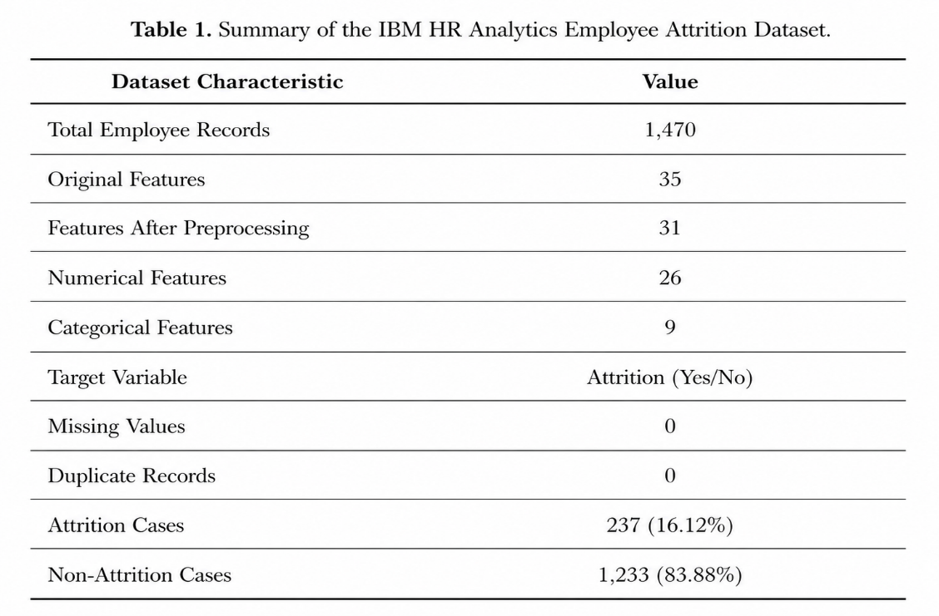
Table 1. Summary of IBM HR data analytics dataset

The dataset includes important variables such as Age, Department, Job Role, Monthly Income, Overtime, Job Satisfaction, Work-Life Balance, Years at Company, Business Travel, Education and Marital Status. These variables provide information about different aspects of an employee's work environment and personal characteristics that may influence employee attrition.
The IBM HR Analytics dataset was selected because of its wide use in previous employee attrition studies and its suitability for comparing different machine learning models. The dataset provides a good representation of HR related attributes and helps in identifying the factors contributing to employee turnover. In addition to employee attrition prediction, the dataset was also used for developing the financial risk assessment framework by combining attrition probability with employee replacement cost estimation.

5.2 Data Preprocessing
Data preprocessing was performed to improve the quality of the dataset before developing the machine learning models. Initially, irrelevant and non-informative identifier columns were removed because they do not contribute to employee attrition prediction and may introduce unnecessary bias during model training.
The target variable Attrition was converted into binary numerical values where Yes = 1 and No = 0, allowing the dataset to be used for binary classification. The categorical variables were converted into numerical values using Label Encoding, ensuring compatibility with the machine learning algorithms while preserving the original category information.
Since Logistic Regression is sensitive to differences in feature scales, the numerical variables were standardized using Standard Scaler. This transformed the variables to have zero mean and unit variance, improving model convergence during training. Feature scaling was not applied to the Random Forest model because tree-based algorithms are not affected by differences in feature scales.
After preprocessing, the dataset was divided into 80% training data and 20% testing data using a fixed random state of 42 to ensure reproducibility of the results. The dataset was also examined for missing values, duplicate records and inconsistencies before model development. No significant missing values were found; therefore, the dataset was used without performing extensive imputation.
These preprocessing steps improved the consistency of the dataset and reduced the possibility of modelling bias, resulting in reliable training and evaluation of the machine learning models.
5.3 Exploratory Data Analysis (EDA)
Exploratory Data Analysis (EDA) was carried out to understand employee behaviour, identify important attrition patterns and support feature selection before developing the machine learning models. Different statistical methods and visualizations were used to study employee characteristics and their relationship with attrition.
The analysis mainly focused on overall attrition rate, department-wise attrition, salary group distribution, employee age, overtime status, job satisfaction, work-life balance and correlation among important variables.
The EDA identified several important insights from the dataset. The overall employee attrition rate was 16.12%, indicating that 237 out of 1,470 employees had left the organization. Among all departments, the Sales department recorded the highest attrition rate, showing greater workforce instability when compared to the other departments. Employees belonging to the Low-Salary group were also found to have a higher probability of leaving the organization, indicating that compensation plays an important role in employee retention.
The analysis also showed that younger employees were more likely to leave the organization than older employees. Employees who worked overtime recorded a considerably higher attrition rate compared to employees who did not work overtime. Similarly, employees with lower job satisfaction and poor work-life balance were found to have a greater chance of employee attrition.
Correlation analysis was also performed to understand the relationship between different employee attributes. The results helped in identifying variables that have greater influence on employee attrition while also checking possible relationships among the features. These findings provided useful business insights and supported the selection of important variables before developing the machine learning models.
5.4 Machine Learning Models
To predict employee attrition, two supervised machine learning classification models were developed and compared. The selected models were Logistic Regression and Random Forest because they are widely used in employee attrition prediction and provide good prediction performance with practical interpretation.
Logistic Regression was used as the baseline classification model because of its simplicity, computational efficiency and easy interpretation. The model predicts the probability of employee attrition using a logistic function and is well suited for binary classification problems.
Before training the model, the numerical variables were standardized using Standard Scaler to improve optimization and model convergence. The performance of the model was evaluated using Accuracy, Precision, Recall, F1-score, Confusion Matrix and Receiver Operating Characteristic (ROC) analysis to obtain a complete assessment of the prediction performance.
Random Forest was implemented as an ensemble machine learning algorithm to capture complex and non-linear relationships among employee attributes. The model was developed using 100 decision trees (n_estimators = 100) with random_state = 42 to ensure reproducibility of the results.
Unlike Logistic Regression, Random Forest does not require feature scaling and performs well even when complex interactions exist among the predictor variables. The final prediction is obtained through majority voting across all the decision trees, which helps reduce overfitting while improving the overall prediction performance.
The performance of Logistic Regression and Random Forest was compared to identify the most suitable model for employee attrition prediction. This comparison helps in selecting a model that provides reliable prediction accuracy along with better interpretation for organizational decision making.
5.5 Explainable Artificial Intelligence (SHAP)
Although prediction accuracy is important, organizations also need to understand the factors influencing employee attrition before making retention decisions. Therefore, SHAP (SHapley Additive exPlanations) was incorporated into the proposed framework to improve the transparency and interpretability of the machine learning model.
SHAP is based on cooperative game theory and assigns contribution values to each feature according to its influence on the prediction. It provides both global and local explanations, allowing the overall importance of features to be identified while also explaining the prediction for individual employees.
The SHAP analysis identified Overtime, Monthly Income, Years at Company, Age and Job Satisfaction as some of the major factors influencing employee attrition. These explanations help HR managers understand why certain employees are predicted to have a higher probability of leaving the organization instead of relying only on prediction scores.
By integrating SHAP into the proposed framework, the study improves the transparency of the machine learning model and increases confidence in the prediction results. It also provides organizations with better insights into employee attrition, enabling more informed workforce planning and retention decisions.
5.6 Financial Risk Framework
To extend predictive analysis into business decision making, this study proposes a Financial Risk Framework that combines machine learning prediction with employee replacement cost estimation. While employee attrition prediction identifies employees who are likely to leave the organization, the proposed framework also estimates the financial impact associated with employee turnover. This helps organizations identify employees whose departure may result in greater financial losses. The proposed framework consists of the following stages:
The first stage predicts employee attrition using the trained machine learning model. Based on the predicted probability, the annual salary of each employee is estimated using the available compensation information.
The employee replacement cost is then calculated using the following relationship:
Replacement Cost = Recruitment Cost + Hiring Cost + Training Cost + Productivity Loss + Administrative Cost

Since detailed organizational cost information is not available in the public dataset, the replacement cost is estimated using the following approximation:
Replacement Cost ≈ 1.5 × Annual Salary

This approximation includes recruitment expenses, onboarding cost, training cost, productivity loss and administrative expenses associated with replacing an employee. The predicted probability of attrition is then combined with the estimated replacement cost to calculate the employee financial risk using the following equation:
Financial Risk Score = Probability of Attrition × Replacement Cost

Based on the calculated financial risk score, employees are classified into Low, Medium and High Financial Risk categories. This classification helps HR managers identify employees who require immediate retention strategies.
Finally, the financial risk scores are integrated into an interactive Power BI dashboard, allowing organizations to analyse financial risk across departments, job roles, salary groups and overtime categories through dynamic visualizations.
By combining machine learning prediction, Explainable Artificial Intelligence and financial risk estimation, the proposed framework provides organizations with a practical decision support system that not only predicts employee attrition but also quantifies its financial impact, enabling better workforce planning and cost-effective human resource management.
- RESULTS AND DISCUSSIONS

6.1 Exploratory Data Analysis (EDA) Findings
Exploratory Data Analysis (EDA) was performed to identify the relationship between employee characteristics and attrition before developing the machine learning models. The analysis helped in understanding employee behaviour and identifying the factors that contribute to employee turnover.
The dataset consisted of 1,470 employee records, out of which 237 employees had left the organization, resulting in an overall attrition rate of 16.12%. Department-wise analysis showed that the Sales department recorded the highest attrition rate of 20.63%, followed by the Human Resources department with 19.05%. This indicates that these departments experience greater workforce instability compared to the other departments.
Salary was also found to influence employee attrition. Employees belonging to the Low-Salary group recorded the highest attrition rate of 29.27%, showing that lower compensation is associated with a higher probability of leaving the organization. Age analysis showed a weak negative correlation with attrition (r = -0.159), indicating that younger employees are more likely to leave than older employees.
Overtime was identified as one of the strongest factors affecting employee attrition. Employees who worked overtime recorded an attrition rate of 30.53%, whereas employees who did not work overtime showed an attrition rate of only 10.44%. This indicates that employees working overtime are considerably more likely to leave the organization.
Job satisfaction also showed a negative relationship with employee attrition (r = -0.103). Employees with lower job satisfaction were more likely to resign compared to employees with higher satisfaction levels. The EDA findings indicate that factors such as salary, overtime, age, department and job satisfaction have a significant influence on employee attrition. These findings also helped in selecting the important variables for developing the machine learning models.

6.2 Logistic Regression Performance
Logistic Regression was developed as the baseline machine learning model for employee attrition prediction. Before training the model, the numerical variables were standardized using Standard Scaler to improve model convergence. The model was trained using the training dataset and its performance was evaluated on the testing dataset using standard classification metrics.
The Logistic Regression model achieved an accuracy of 87.76%, precision of 55%, recall of 44% and an F1-score of 49%. These results indicate that the model provides reliable prediction performance while maintaining good interpretability, making it suitable for employee attrition prediction.
One of the major advantages of Logistic Regression is that it predicts the probability of employee attrition using a logistic function, allowing the influence of each predictor variable to be easily interpreted. This enables HR managers to understand how different employee characteristics contribute to attrition risk and supports better decision making.
However, Logistic Regression assumes a linear relationship between the predictor variables and the probability of employee attrition. Since employee behaviour is influenced by several demographic, organizational and behavioural factors, the model may not capture complex non-linear relationships present in the dataset. Despite this limitation, the model provides meaningful insights into employee attrition and serves as an effective prediction model for proactive workforce planning.

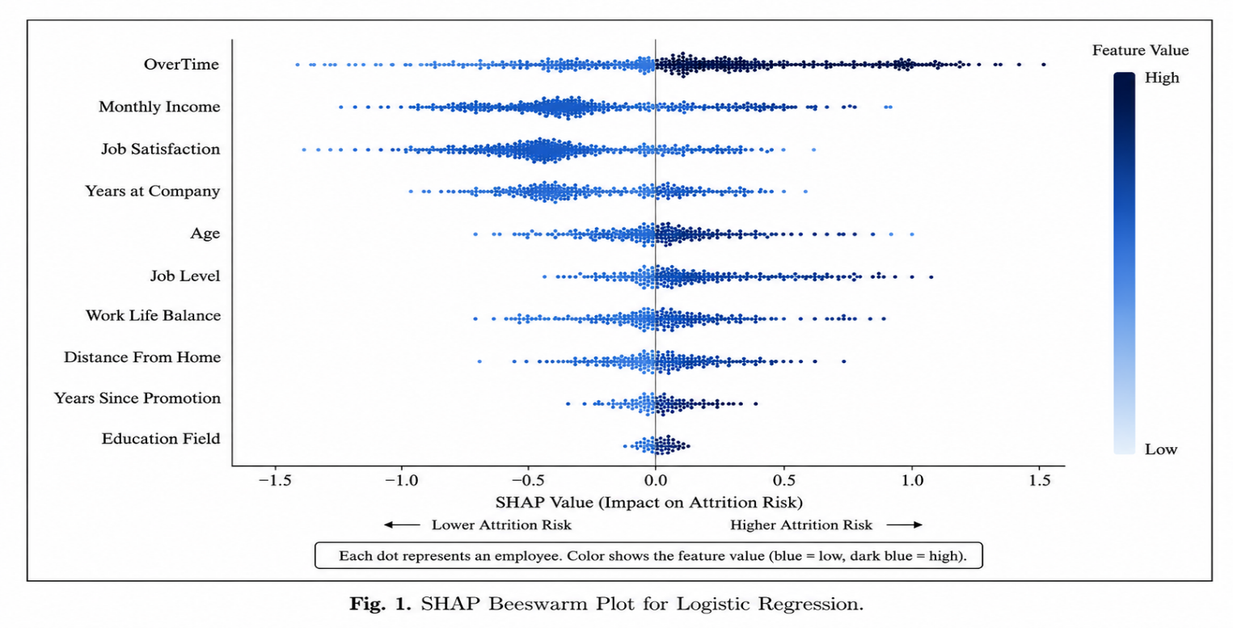
Fig.1 SHAP bee swarm plot for logistic regression
6.3 Random Forest Performance
Random Forest was developed as the second machine learning model to predict employee attrition. The model was implemented using 100 decision trees (n_estimators = 100) with random_state = 42 to ensure reproducibility of the results. Unlike Logistic Regression, Random Forest does not require feature scaling and can identify complex relationships among employee attributes.
The Random Forest model achieved an accuracy of 87.41%, precision of 67%, recall of 10% and an F1-score of 18%. Although the model produced a higher precision than Logistic Regression, the recall was considerably lower. This indicates that the model identified fewer employees who were at risk of leaving the organization.
The model was able to capture non-linear relationships among important variables such as Overtime, Monthly Income, Age, Job Satisfaction, Years at Company and Department. It also reduced the possibility of overfitting by combining predictions from multiple decision trees and automatically estimated the importance of different features.
Despite its ability to model complex relationships and achieve good overall accuracy, the low recall and F1-score limited its effectiveness for proactive employee attrition prediction. For this reason, Logistic Regression was selected as the preferred model for the proposed framework because it provided better overall performance in identifying employees at risk of attrition.
6.4 Comparative Analysis of Machine Learning Models
Logistic Regression and Random Forest were developed and evaluated using the same training and testing dataset to compare their prediction performance. The models were assessed using different evaluation metrics including accuracy, precision, recall and F1-score. In addition, factors such as model interpretability, feature scaling and the ability to capture complex relationships were also considered.
Logistic Regression achieved an accuracy of 87.76%, precision of 55%, recall of 44% and an F1-score of 49%. The model provides good interpretability and predicts the probability of employee attrition, allowing organizations to understand the influence of different employee attributes.
Although it assumes a linear relationship among variables, it achieved better recall and F1-score, making it more effective in identifying employees who are likely to leave the organization.
Random Forest achieved an accuracy of 87.41%, precision of 67%, recall of 10% and an F1-score of 18%. The model was able to capture complex and non-linear relationships among employee characteristics and automatically estimate feature importance. However, the lower recall indicates that the model failed to identify many employees who were at risk of attrition.
The comparison shows that both models achieved similar accuracy, but Logistic Regression provided better overall performance for employee attrition prediction. Since identifying employees who are likely to leave is more important than achieving higher precision alone, Logistic Regression was selected as the final prediction model for the proposed Employee Attrition and Financial Risk Prediction Framework.

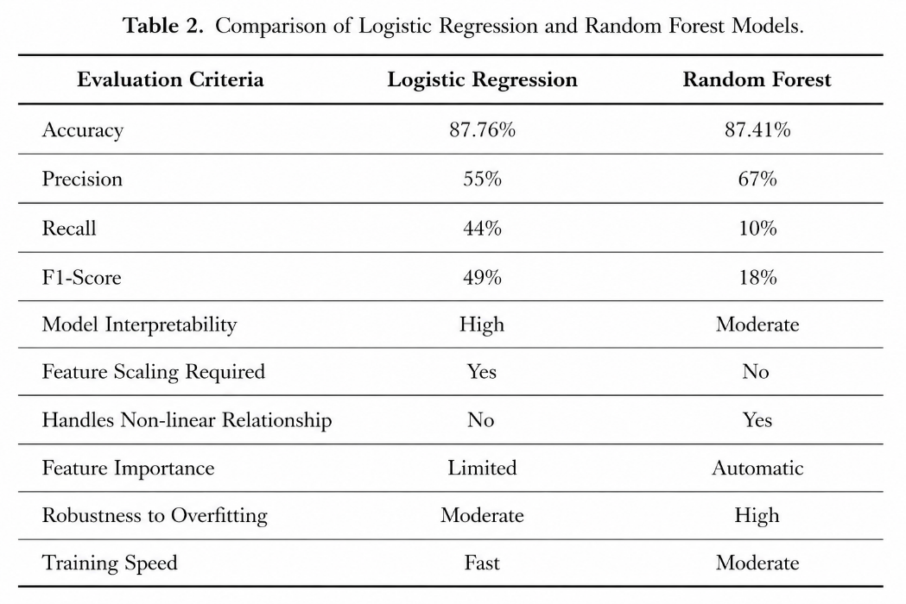
Table 2. Comparison of logistic regression and random forest models

The results indicate that Logistic Regression provides a better balance between prediction performance and model interpretability. Although Random Forest achieved higher precision, its low recall reduced its ability to identify employees at risk of leaving. Therefore, Logistic Regression was selected as the preferred model for this study.

- EXPLAINABLE ARTIFICIAL INTELLIGENCE (SHAP)
Although the Logistic Regression model provides good prediction performance, organizations also need to understand the factors influencing employee attrition before making retention decisions. Therefore, SHAP (SHapley Additive exPlanations) was used to improve the transparency and interpretability of the prediction model.
SHAP assigns contribution values to each feature based on its influence on the prediction. It explains both the overall importance of the variables in the model and the contribution of each variable towards the prediction of an individual employee. This helps organizations understand why an employee is predicted to have a higher probability of leaving instead of relying only on the prediction score.

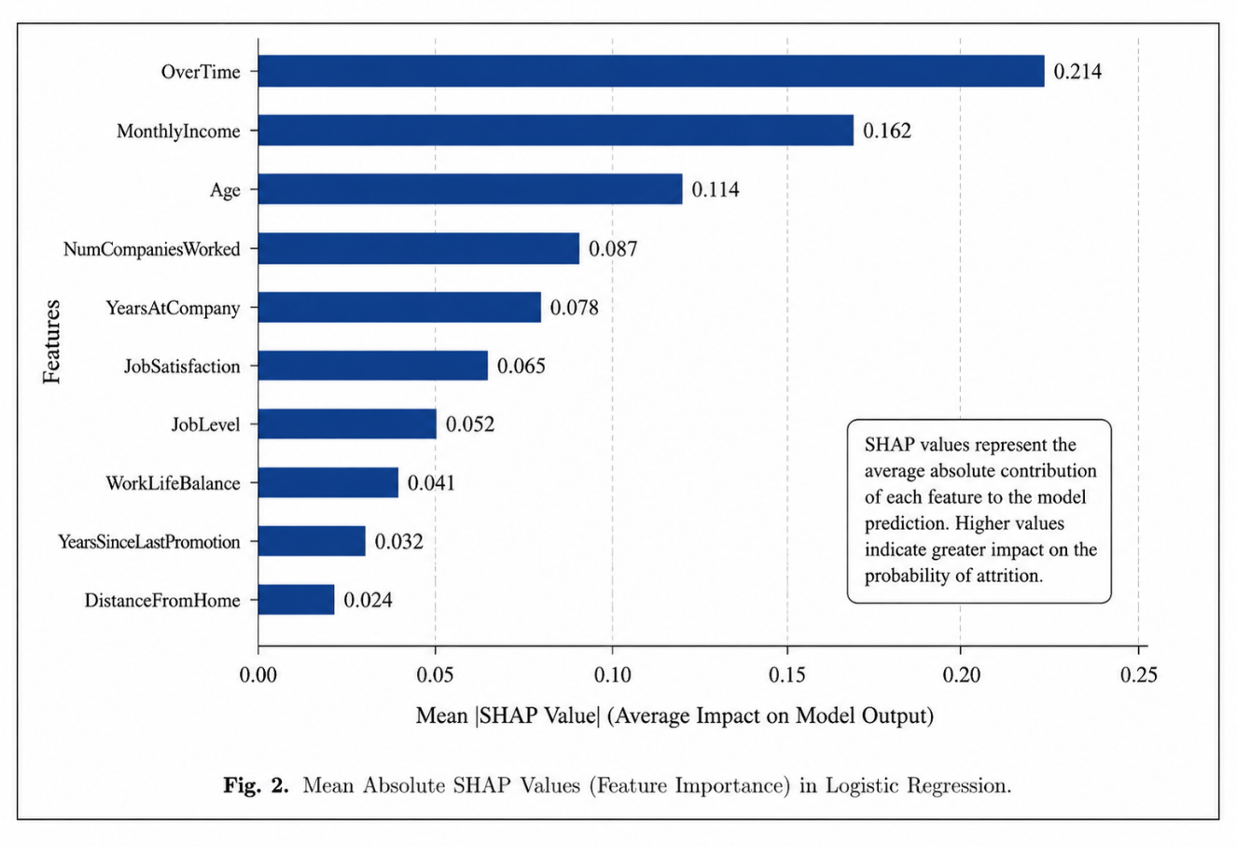

Fig.2 SHAP summary plot

The SHAP analysis identified Over Time, Monthly Income, Job Satisfaction, Age, Years at Company and Job Role as the major factors influencing employee attrition. Employees working overtime, receiving lower monthly income, reporting lower job satisfaction and having fewer years at the company were found to have a higher probability of leaving the organization. Similarly, employee age and job role also contributed to the prediction of attrition.
The explanations generated by SHAP provide useful insights for HR managers by identifying the factors responsible for employee attrition. This enables organizations to design better retention strategies for employees who are at higher risk of leaving.
By integrating Explainable Artificial Intelligence into the proposed framework, the study improves the transparency of the machine learning model and increases confidence in the prediction results. It also supports better workforce planning by helping organizations understand the reasons behind employee attrition.

- BUSINESS DISCUSSION

The findings of this study show that machine learning can be used as an effective decision support tool for employee retention. Instead of identifying employee turnover after resignation occurs, the proposed framework predicts employees who are likely to leave the organization in advance. This enables organizations to take timely action and implement suitable retention strategies.
The integration of machine learning, Explainable Artificial Intelligence (SHAP) and financial risk assessment extends traditional employee attrition prediction into a practical business framework. By combining attrition probability with employee replacement cost, organizations can identify not only employees who are likely to leave but also those whose departure may result in higher financial losses.
The proposed framework provides several benefits for organizations. It helps HR managers identify high attrition risk employees at an early stage and prioritize retention efforts based on financial impact. The framework also supports reduction in recruitment, hiring, training and productivity loss costs associated with employee turnover. In addition, it improves workforce planning by helping organizations allocate their resources more effectively.The use of SHAP improves the transparency of the machine learning model by explaining the factors influencing employee attrition. The interactive Power BI dashboard further supports decision making by allowing HR managers to monitor attrition risk and financial impact across different departments, job roles, salary groups and overtime categories.
The results demonstrate that combining machine learning, Explainable Artificial Intelligence, financial risk estimation and business intelligence visualization provides organizations with a practical decision support system. This enables organizations to make data driven retention decisions, reduce employee turnover costs and improve overall workforce management.

- CONCLUSION
Employee attrition has become a major concern for organizations due to its impact on workforce stability, productivity and overall organizational cost. This study proposed an integrated Employee Attrition Prediction and Financial Risk Assessment Framework by combining Machine Learning, Explainable Artificial Intelligence (SHAP), financial risk estimation and interactive business intelligence visualization.
The Exploratory Data Analysis identified several factors based on which, Logistic Regression and Random Forest models were developed and evaluated. Logistic Regression achieved the best overall performance with an accuracy of 87.76%, precision of 55%, recall of 44% and an F1-score of 49%. Although Random Forest achieved higher precision, its low recall reduced its ability to identify employees at risk of leaving. Therefore, Logistic Regression was selected as the final prediction model for this study.
To improve the transparency of the prediction model, SHAP was incorporated to identify the major factors influencing employee attrition and explain the prediction results. The study also proposed a financial risk assessment framework by combining attrition probability with employee replacement cost estimation. The calculated financial risk scores were presented through an interactive Power BI dashboard, allowing organizations to monitor workforce risk and support employee retention strategies.
The proposed framework provides organizations with a practical decision support system that not only predicts employee attrition but also quantifies its financial impact. By integrating predictive analysis, Explainable Artificial Intelligence and financial risk assessment, the framework enables organizations to make better workforce planning decisions, prioritize employee retention and reduce the overall cost associated with employee turnover.
- FUTURE SCOPE
Although the proposed framework provides good prediction performance and practical business insights, there is still scope for further improvement. Future studies can evaluate advanced machine learning models such as XGBoost, LightGBM, CatBoost and Deep Neural Networks to improve the prediction accuracy and compare their performance with the models used in this study.
The framework can also be improved by integrating real-time HR data, allowing organizations to continuously monitor employee attrition and update prediction results. The inclusion of additional factors such as labour market conditions, economic indicators, organizational culture and employee engagement may further improve the performance of the prediction model.
Future research can also focus on developing personalized employee retention recommendations using Explainable Artificial Intelligence. This would help HR managers identify suitable retention strategies for employees who are at higher risk of leaving the organization.
The proposed framework can be validated using datasets collected from different industries and organizations to evaluate its applicability in various business environments. Using real organizational replacement cost data instead of estimated costs can also improve the accuracy of the financial risk assessment.
Finally, the proposed framework can be deployed as a web-based application or integrated with Human Resource Information Systems (HRIS) and Enterprise Resource Planning (ERP) systems. This would enable organizations to monitor employee attrition in real time and support better workforce planning.

An interactive demonstration of the developed dashboard is available at: https://ashtondsz.github.io/Employee-Risk-Analytics
The complete implementation, source code, and supporting file can be accessed via the GitHub repository: https://github.com/ashtondsz/Employee-Risk-Analytics

REFERENCES
- Raza, M., et al.: Employee Attrition Prediction Using Machine Learning. 2022.
- Benabou A., et al.: Machine Learning Models for Employee Attrition Prediction. 2025.
- Mhatre, S., et al.: Employee Attrition Prediction in the BPO Industry. 2020.
- Yahia, A., et al.: Machine Learning and Deep Learning for Employee Turnover Prediction. 2021.
- Park, J., et al.: Employee Turnover Intention Prediction Using XGBoost. 2024.
- Al-Ali, M., et al.: Explainable Employee Attrition Prediction Using SHAP. 2026.
- Marín Díaz, J., et al.: Explainable AI Frameworks for HR Analytics. 2023.
- Nimmagadda, R., et al.: Employee Attrition Analysis Using Logistic Regression. 2024.
- Tang, Y., et al.: Employee Attrition Prediction Using Random Forest and SMOTE. 2025.
- Noorul Khathija, Hussain: Employee Retention: A Mixed-Method Study. 2025.
- Prasanth, Vasanth: Employee Attrition Analysis Using Power BI and R. 2023.
- Iyiade, O., et al.: A Systematic Review of Employee Attrition Prediction Models. 2025.
- Akter, Maruf: Workforce Forecasting and Predictive HR Analytics. 2025.
- Duda, J., Žůrková, H.: Employee Turnover Cost Framework. 2013
- Hinkin, T.R., Tracey, J.B.: The Costs of Employee Turnover. 2006.
- O'Connell, M., Kung, M.: The Hidden Costs of Employee Turnover. 2005.
- Strategic Employee Retention Study: Employee Retention and Workforce Stability. 2025..

